This tutorial will teach you how to make and animate snow for a sig or banner.

1. Open up your image that you want to apply the snow to.
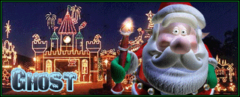
2. Make a new layer where you want your snow to be. (Most likely on top). Fill it with black #000000
3. Press Filter > Noise > Add Noise and use the following settings.
Amount: 70%
Distribution: Gaussian
Monochromatic: Yes
This will create a black background with white dots.
4. Change the layer mode to Screen. This will make it so the background can be seen through the snow layer.
5. Press Filter > Blur > Gaussian Blur, and use the following settings:
Radius: 1.5 pixels
6. Press CTRL+L to bring up the levels dialogue box. Change the options to:
Channel: RGB
Input Levels: 90, 1.00, 120
Output Levels: 0, 255
Press OK.
7. Repeat steps 2-6 by making new layers. Do NOT duplicate them, as the Noise on each layer will be the same. We want them to be different. For example, on the 2nd snow layer, make the noise on 71%. On the 3rd layer, make it 72%, etc. Repeat these steps 4 more times so you have a total of 4 layers of snow.

8. Press the "Edit in Image Ready" button
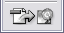
to start the animation stage.
9. Create a total of 5 frames (One frame for each snow layer). Click on the first frame, and make only the background image, and first snow layer visible. Click on the 2nd frame, and make only the background image and 2nd snow layer visible, etc.
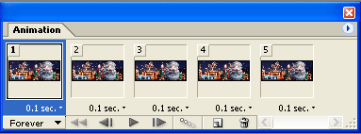
Now change each frame time to 0.1 seconds. Press File > Save Optimized As... and your done!
Here's my final result:

A masterclass on creating fake real world effects in Photoshop. Part three - creating snow.
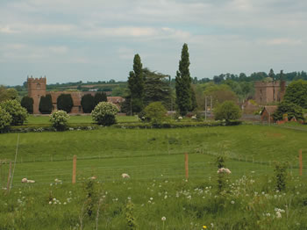
Sometimes a winter image is required and the only image available is a summer scene. Green grass, green leaves, and warm summer daylight all have to be transformed to change the season. Here, we’ll take a distinctly summery photo and dress it in a blanket of snow, adding a blizzard for good measure. For a relatively simple technique that uses a few common Photoshop techniques in combination, the end result is surprisingly convincing. Let it snow!

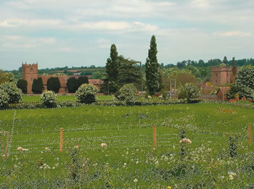
- First, we need to generate a layer of snow to cover the ground and trees in this summertime image. Choose the Eyedropper tool from the Toolbar and click in the field to sample a mid-green colour. We now need to make a selection based on the distribution of this colour throughout the image. Go to Select > Color Range. Use a Fuzziness slider setting of 132 and choose Sampled Color from the Select box. Click OK.
- 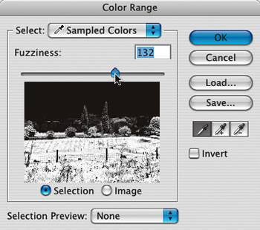

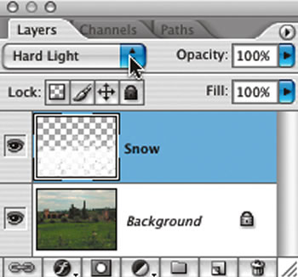
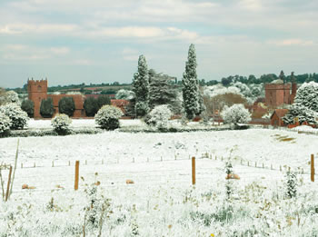
2. Add a new layer (Ctrl/Cmd+Shift+N), naming it “Snow.” We need to fill this active selection with white to begin the snow effect, so go to Edit > Fill, and choose White for Contents. Hit Ctrl/Cmd+D to deselect. In the Layers palette, change the blending mode of the Snow layer to Hard Light.
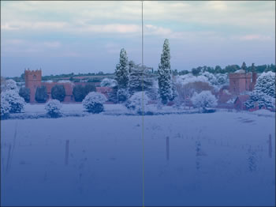
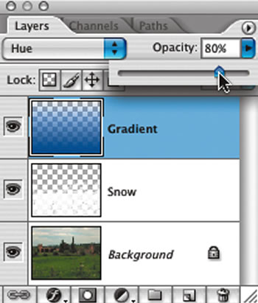
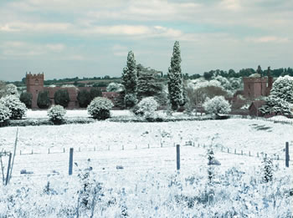
3. The image needs to be made a little colder now. Add another layer, call it “Gradient", and click in the foreground colour swatch, choosing a vibrant blue/violet. Select the Gradient tool from the Toolbar and click in the Gradient Picker, choosing Foreground To Transparent. Click and hold with the tool at the bottom of the image and drag the gradient guide vertically to the top. Set the blending mode for this layer to Hue and the layer opacity to 80 per cent.
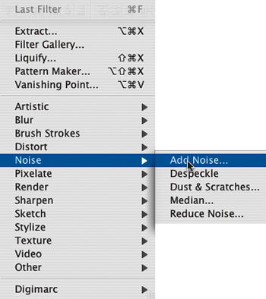
4. Now to add some snow. Add another new layer (Ctrl/Cmd+Shift+N) naming it “Snowfall.” Fill this layer with 50 per cent grey using Edit > Fill > Contents: 50% Grey. To begin creating the snowfall, we need to add some random noise to this layer. Hit D on the keyboard to revert to default black/white colours, and go to Filter > Noise > Add Noise.
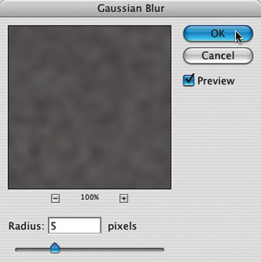
5. In the Add Noise dialog box, drag the Amount slider up to 50%. Choose Gaussian for Distribution and check the Monochromatic check box. Click OK. This noise is too fine for a snow effect, so blur this layer using Filter > Blur > Gaussian Blur. Use a Blur Radius of five pixels to clump the noise a little.
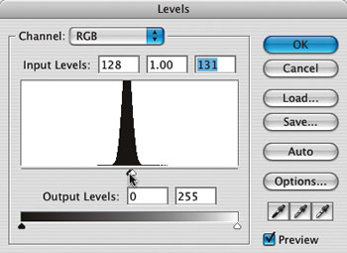
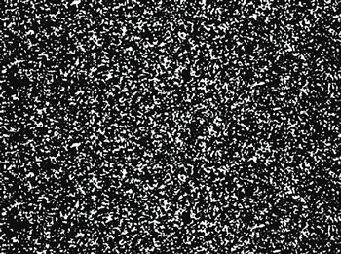
6. We need to adjust the contrast of this layer. Do this using Image > Adjustments > Levels. In the Levels dialog box, grab the White Point marker and drag it to the left until it’s below the center of the histogram peak. Now drag the Black Point marker to the right until it almost disappears behind the white marker. Click OK.
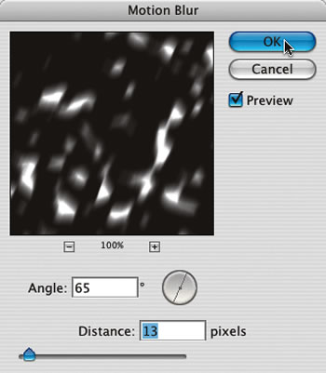
7. Set the blending mode of the Snowfall layer to Screen and reduce the opacity to about 50 per cent to allow the landscape to show through the snow. To blur the snow a little, and to give the impression of it being blown by the wind, go to Filter > Blur > Motion Blur. Use an Angle of 65 degrees and a Distance of 13 pixels.
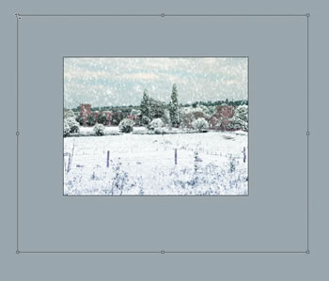
8. Adding a few larger snowflakes will give the impression of distance. Duplicate the Snowfall layer (Ctrl/Cmd+J) and go to Edit > Transform > Flip Horizontal. Zoom out from the image using the Zoom tool and go to Image > Transform > Scale. Lock the chain-link in the Options bar to constrain the proportions and drag the corner handle on the bounding box outward. Hit the Enter key to commit the Transformation.
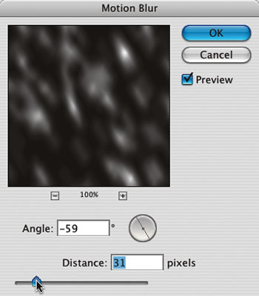
9. Finally, on this duplicate Snowfall layer, go to Filter > Blur > Motion Blur. We want to blow this snow in the other direction, so use an Angle of -59 and a Distance of 31. If the landscape is not showing sufficiently, reduce the opacity of the two Snowfall layers a little more.
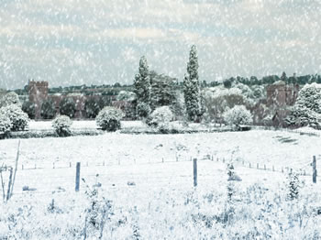
Tim Shelbourne

Creating and Animating Snowfall
We start by opening an image of a snowman.
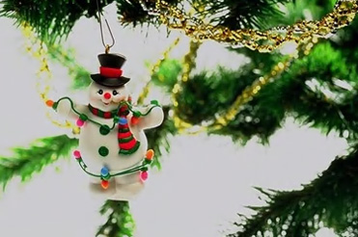
Select brush tool and press shift F5 to open brush settings. Adjust brush settings as shown.
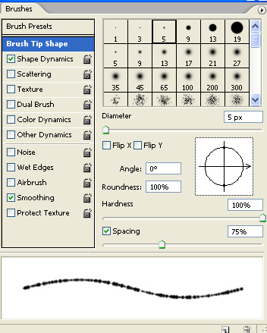
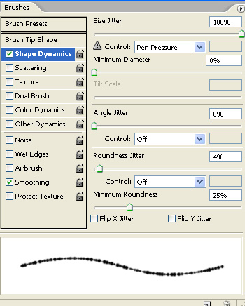
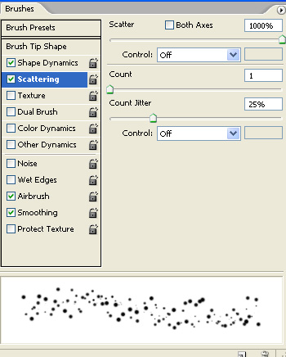
Using white as a foreground color apply the brush over the image in a new layer.

Duplicate the layer and move it up so that bottom of this image touch the top of the original snow layer. Merge both snow layers.
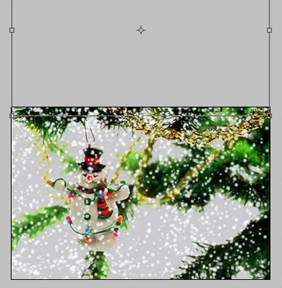
Open animation window. For the first frame leave the snow frame as it is.
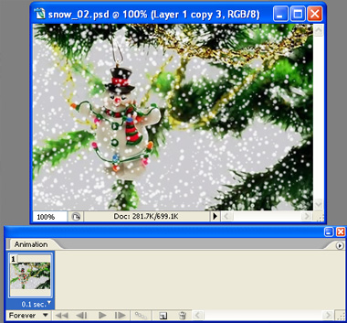
Duplicate the frame and move the snow layer downwards so that the top of snow layer touches the top of the image.
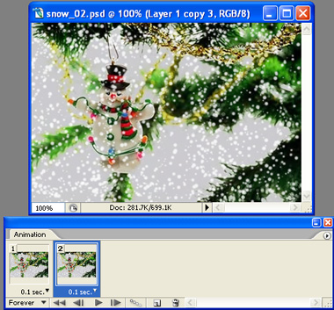
Select both frames and press tweens animation frames in animation window.
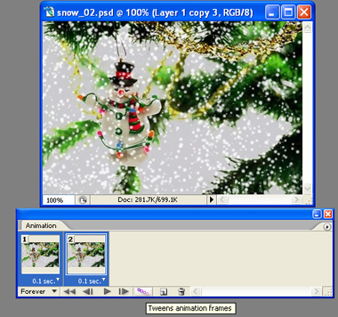
Adjust the settings in tween window as shown.
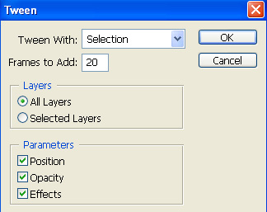
Tweening will create in between frames automatically.
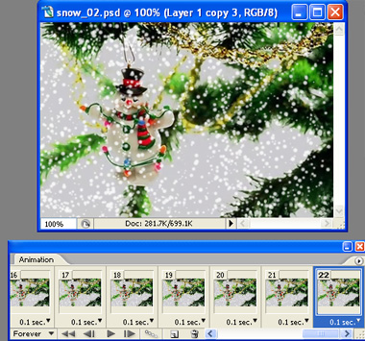
Delete the last frame to create a seamless loop of snowfall animation. Adjust delay durations as shown in the shot below.
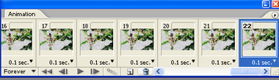


Original photo. Northern Finland, not far from the polar circle:
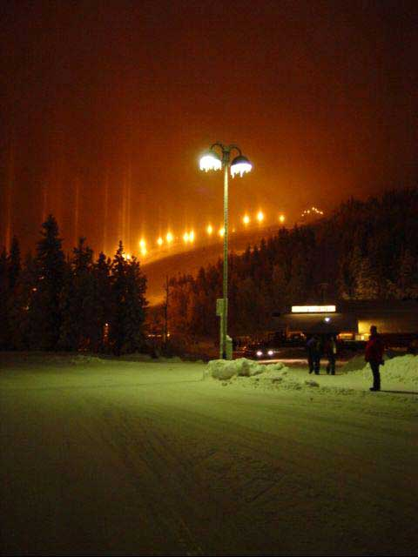
Let's try to add little snow to it.
Step 1. Duplicate background.
As usual, begin with pressing CTRL-J to duplicate "Background" layer. That will let you have a "backup" of the orginal image if something goes wrong.
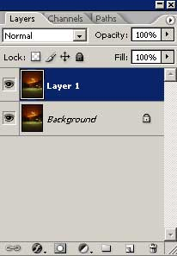
Step 2. Create "Snow" layer filled with white.
Press CTRL-SHIFT-N to create new layer. Give it a name "Snow".
Press SHIFT-F5 to fill new layer with white.
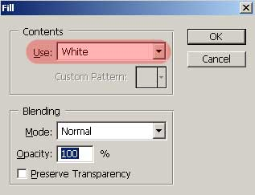

Step 3. Fill "Snow" layer with noise.
Select Filter - Noise - Add Noise.
Set Noise Amount to 100-150%, Gaussian distribution, Monochromatic NOT checked.
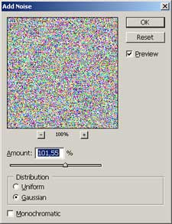

Step 4. Increase noise size.
Press CTRL-A to Select All, then CTRL-T to Transform.
Use numeric input in the upper part of the window, set vertical and horizontal scale to 150-200%.
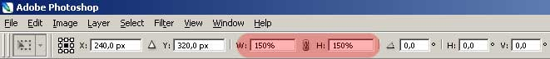

Step 5. Set blending mode of "Snow" layer to "Screen".
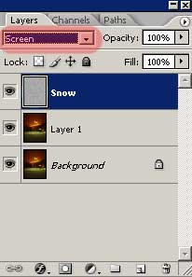
Step 6. Convert noise to snow.
Use Image - Adjustments - Threshold. Set Threshold amount to 200-240, depending on how much snow you want.
Select Filter - Blur - Gaussian Blur. Set Radius to 0,5 - 1 pixels. Do not blur snow too much at this step.
My values are: Threshold - 243, Gaussian blur - 0,6 pixels.
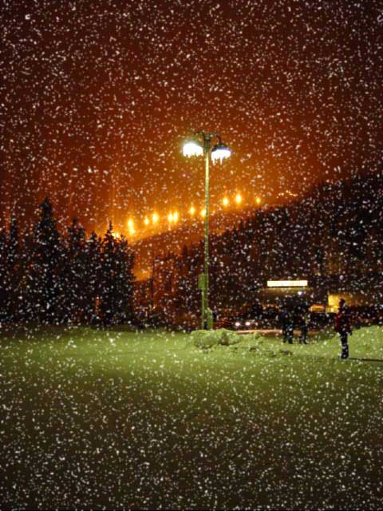

Step 7. Make snow fall.
Select Filter - Blur - Motion Blur. Set Distance to 8-12 pixels and try various directions.
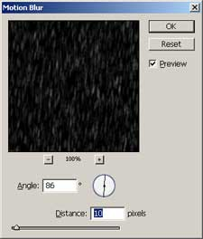

Step 8. Ideas for further adjustments.
Image after some editing:

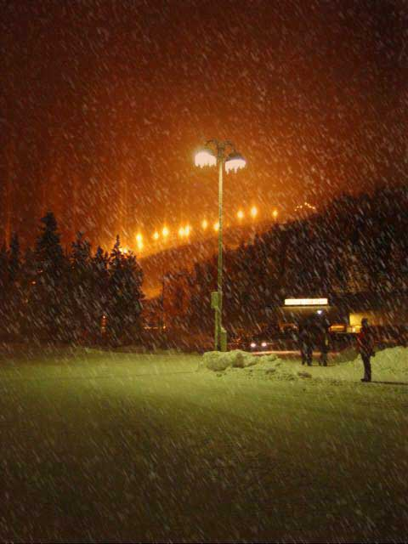

Step 1
Open up the image you desire to add the rain effect to. I'll be using this one:
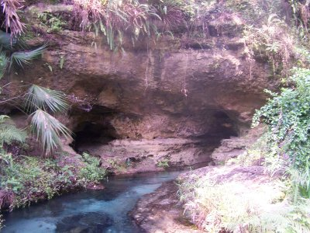
Step 2
Duplicate the image 2 or 3 more times. I'm duplicating mine twice.
Step 3
Add 1 new layer for each number of background image layers and fill them with white. Since I have a total of 3 background layers, I now have 3 white layers as well (a total of 6 layers).
Step 4
Re-order the layers so that you have a background layer with a white layer on top of it. The layers should alternate like so:
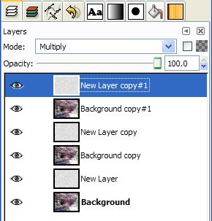
Step 5
Add some noise to each white layer by going to Filters | Noise | Scatter RGB. I've used the following settings, but you can experiment a bit:
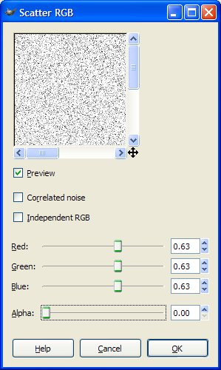
It's really not necessary to change the settings of the noise filter as the noise is placed randomly. After I got the settings I wanted, I just made each white layer active and hit Ctrl-F to repeat the filter with the previous settings. You can change the settings if you want, but I'm just letting you know it isn't necessary.
Step 6
Now add a motion blur to each noise layer. Here's my settings:
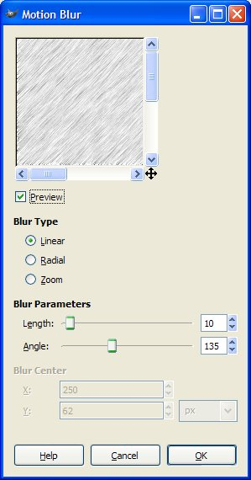
Step 7
Now, set the layer blend mode for each of the noise layers to "Multiply" (or some other blend mode that suits your taste.)
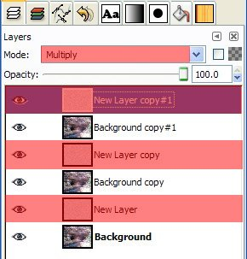
Step 8
Merge each one of the noise layers down to the background image below it. Menu: Layer | Merge Down. I now have 3 background layers with rain.
This is what my layers look like:
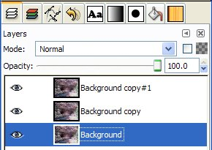
Step 9
Now, try out your rain.....Filters | Animation | Playback
Step 10
Optimize it for animation: Filters | Animation | Optimize for GIF
Step 11
Save as a GIF
Step 12
When you see this window, please set the options as follows:
Here's my results once more:


